**Experiment 8 Date:** 21/03/2023

Aim:

Familiarization of Linux Commands

Course Outcome(CO2):

Perform system administration task

Procedure:

1. ip addr:- Get ip address of the system

$ip addr

Output:

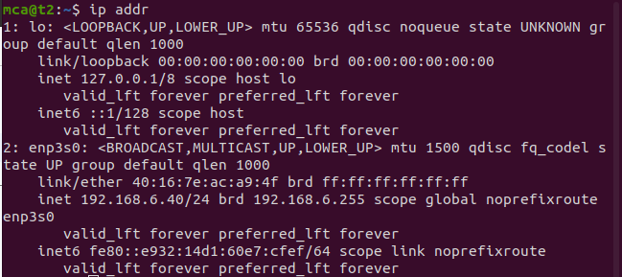

1. ssh user@ip address:- Stands for Secure Shell Protocol used to securely connect to a remote server or system. ssh is secure in the sense that it transfers data in encrypted form between host and client.

$ssh mca@192.168.6.39

Output:



* 1. sudo apt-get install openssh -server :- Update port
  2. sudo ufw allow 22

$sudo ufw allow 22

Output:

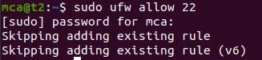

* 1. $ssh mca@192.168.6.28

Output:

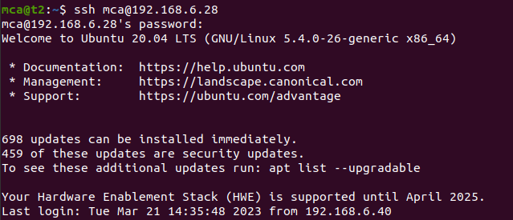

* 1. ssh-keygen :- Generating a key for secure shell

$ssh-keygen

Output:

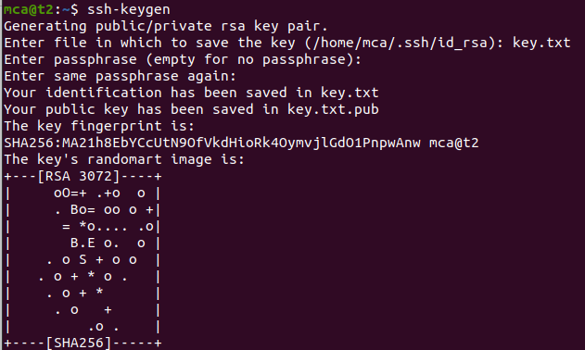

1. ps :- Stands for Process. Currently running programs and running instances.
   1. $ps

Output:

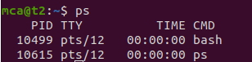

* 1. ps -u :- Display all running processes of a particular user

$ps -u mca

Output:

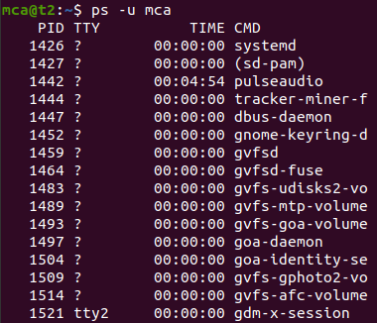

* 1. ps -C :- Specific process

$ps -C firefox

Output:



* 1. ps -f –p PID :- List the process by id

$ps -f -p 2762

Output:

